Note: Include this page only when adding / amending / deleting a document. If using this document as a record, this Revision History page can be omitted.

REVISION HISTORY

Revision no | Date | Description of Changes | Reason for Revision | Revised by | Approved by
1 | 19 Apr 13 | - Add revision history page | - Recommendation from Stage 2 audit | RDPlacido
2 | 8 Apr 16 | Added disclaimer when printing the document  Removed documents that are not being used | For document control | RCGanal | ECVentura
TM-BR-MG- 11 Rev02, 10302016

- Objective
To ensure that all quality records are properly identified, controlled, maintained and disposed of.
- Scope
This procedure defines the action and responsibilities of the Document Controller, the Unit heads and the document custodians of each unit in the proper handling of the company’s records related to quality management. This includes activities that start from the document control staff receiving the records until such time when obsolete records are disposed of.
- Definition of Terms
QMR | Quality Management Representative
DC | Document Controller

- Procedure Details
RESPONSIBLE | ACTIVITY | INTERFACE
Document & Records Custodian  DC | 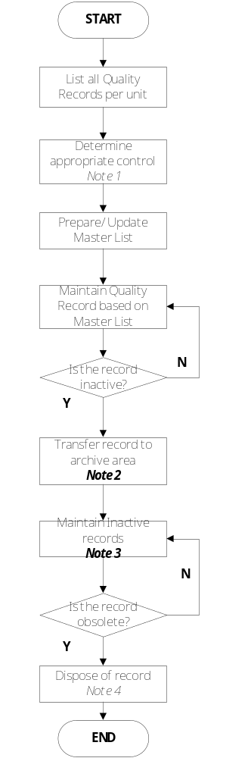 | Master List of Quality Records  Unit Heads

Notes:

- Master List of Records should include the following:
- Filing Method
- Specific File Location
- Retention Period for inactive and active records
- Disposal Method
- Person responsible for safekeeping

- For hardcopies, a Box Storage Label should be used to identify the contents of the box in which archived records are to be stored. Inform the unit head that the records are being transferred.

- When the Unit Head or any authorized staff would like to access inactive files, the QMR should be notified through email.

- Dispose of obsolete records either by shredding or recycling.

- References
None.
- Quality Records
- Master List of Quality Records

